**SOFTWARE DEVELOPMENT PROPOSAL | Business Plan**

PREPARED FOR: University of South Africa (UNISA)

PREPARED BY: Ralph Botes, 65614968

DATE: 2022-10-05



DEAR UNISA,

RE: Enclosed Software Development Proposal

As a post-graduate with my diploma in IT, which I acquired from your fine university, I come to you with not only the knowledge to design the system in question, but also with the experience of the system currently being used.

I’ve had my fair share of issues and experienced first hand some bugs, and key problem areas while working with the system.

I bring thus to you the skills, expertise and experience to create an Online examination file submission system that not only fit your needs and requirements, but also eliminate the known issues you currently have on hand.

I will present to you a system that is built with great care and can easily be adapted to your needs over time without the need to re-develop the system in the foreseeable future.

I’m looking forward in joining you on your new journey.

Regards

Ralph Botes

65614968

Contents

Project Overview 3

Technology requirements 4

Hardware 4

Software 4

Obstacles 4

Deployment 5

Installation 5

Training 5

Testing 6

Backup and recovery 6

Documentation 6

Reporting 6

Evidence 6

# Project Overview

As you are moving from a semi-online university to a fully-online university with regards to examinations, an Online examination file submission system will need to be crated.

The design aims to enable students, lecturers, and your examination department to easily interact with the system, each with their own uniquely suited dashboard with the ability to allow each user to access the required documents, handle uploads and downloads and access, view, and or modify data easily.

The system will have 3 key users:

* Students
* Lectures
* Exam department staff

**Students** will be able to view their exams and exam dates, and will be permitted to be able to download their exam on exam day within a specified timeframe, and be able to upload their exam again if they are still within the time limit. Uploads and downloads are only permitted and enabled during these times.

**Lecturers** will be able to upload exams on their dashboard. They will be notified on exam completion and will be able to view each submission.

**Exam Department** will be the authority users, they will be able to set exam dates, and view MIS reports.

The system will be a web-based application that will run on a web server where each user will be able to access the system if they possess the correct credentials.

The project will be built using a software called WebDev 27. This tool uses a 5th generation language called WLanguage that is unique and easy to work with. This will massively reduce the time that will be needed to build the system.

The software will be distributed on a server of your choice where the required tools and software will be installed to handle the system and database.

You will retain ownership once testing has completed and turnover is finalized with an exclusive 10-year warranty.

Continued support during development and after deployment will remain active.

# Technology requirements

## Hardware

The system will be web based and so will be able to run on any internet browser.

The system can be accessed from any Desktop/ Laptop (Windows, Mac and Linux), as well as from a smartphone (iPhone, Android) with an internet connection (required).

The system itself will need to be loaded on a server that will be able to handle large amounts of traffic (students, Lectors, and Exam Department users will access the system).

The server can be either Windows, or Linux. The “WEBDEV Application Server - 10 Connections” tool allows me to easily manage the server configuration for deployment.

## Software

The system will be developed with WebDev 27. WEBDEV is a full development environment that includes all the tools required for developing and maintaining Internet or Intranet sites in many fields:

* E-commerce (sales, rentals, bookings...),
* Multimedia (description of companies, "showroom" sites...),
* Intranet (logins, secure accesses...),
* And more

Unlike other programming languages, there is no need to find and add modules to be able to design, check and deploy a site. This reduces design time and helps speed up deployment.

## Obstacles

Integration from an existing database to a new database is always a hassle. WebDev allows me to easily manage existing databases and implement new ones with easy to use included tools and native connectors, which minimizes unexpected errors to occur.

# Deployment

## Installation

Everything will be handled remotely.

After access to the server where the system will be run from is granted, I will install and configure the “WEBDEV Application Server - 10 Connections” tool. This tool will help me configure the deployment server for the system.

When the "WEBDEV Application Server - 10 Connections" is installed, a Windows account will have been created or defined as administrator of the WEBDEV Application Server. This user has all the rights (administration, deployment, statistics).

I can then use the Hosting Control Centre to configure the different characteristics of this user or to use a specific user to deploy the site. The Hosting Control Centre is a tool designed to automatically configure the following elements:

* WEBDEV Application Server,
* Web server (IIS),
* FTP server (IIS). The FTP server must be configured only for an installation via FTP.

The Hosting Control Centre will then be used to create a deployment account.

This account will be used to deploy the WEBDEV site directly from WEBDEV.

I will then deploy the site via HTTP to the remote WebDev application server I created.

Updates thereafter will be handled with ease using the same principals as deployment.

## Training

Training to lectors and other training personnel will be supplied just before final implementation and sign-off. You can then train other relevant personnel or students internally. Training for updates that require training, will be given in the same manner.

Main/ key lectors and training personel will be required at a set time, before system sign-off, to attend a training webinar where they will receive relevant documentation, notes, and video training material.

Training after sign-off of initial system is optional and can be done on request.

## Testing

From the first test implementation of the system, an UNISA representative (and/or other key personnel) will be required to attend live testing meetings to offer guidance, comments, and/or observations as the testing commences. This will help minimize issues and mis-communication of processes later on and help deliver a final system, quicker.

## Backup and recovery

The backup and recovery of data is handled with the “HFSQL Control Center” tool supplied by WebDev. An automated backup will be set (called a HotBackup) that will ensure daily backup of your site data.

Recovery of data can be handled either remotely or on site using the same tool.

Simplified wizards of these procedures allow us to train personnel on site to do so without the need for you to contact us, if you require so.

## Documentation

Documentation will be added to your server and relevant links will be supplied to you by email.

* Documentation supplied will include:
* User guide
* Database help (if required)
* System help

# Reporting

The system will allow MIS Reports to be viewed by the Exam department users. MIS reports will include detailed:

* Daily reports
* Weekly reports
* Staff reports
* Statistical reports

# Evidence

The following Graphical representations are to give you a look and feel of what we can offer you.

**Home page**

This is a simple home page where general information relating to UNISA and its services can be added.

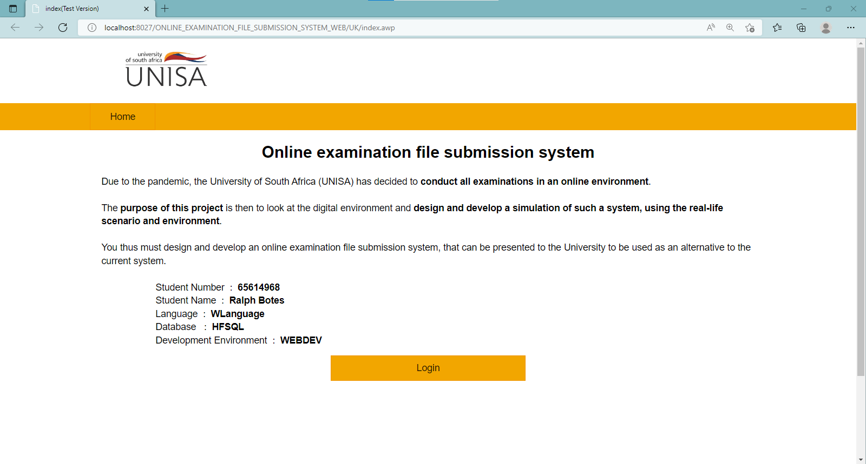

**Student dashboard**

Here, students can view their time tables for their exams, download exam papers and upload their exams in one simple page. Each module a student is registered for are displayed for them individually.

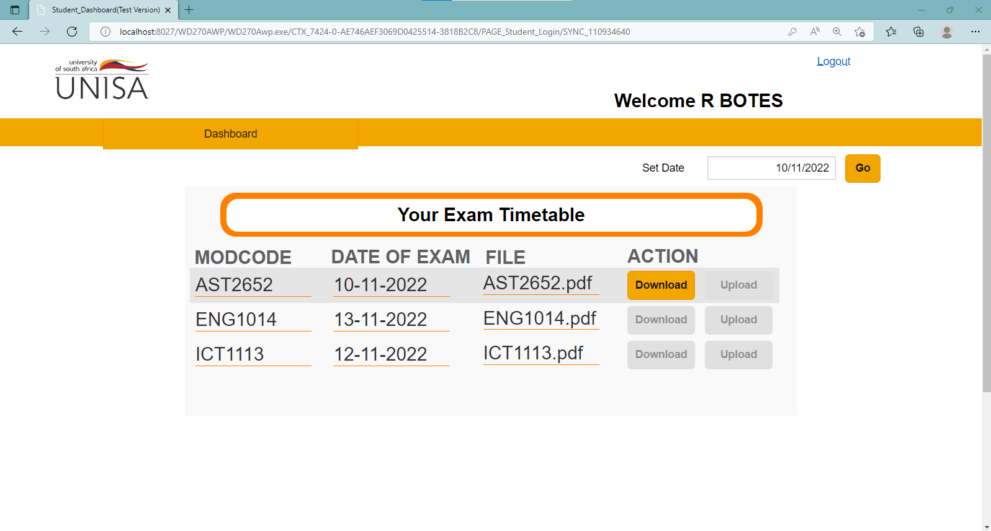

**Lector exam viewer**

The lector can use the exam viewer tree to access the modules they are permitted to view, and view each submitted exam pdf folder in an online pdf viewer.

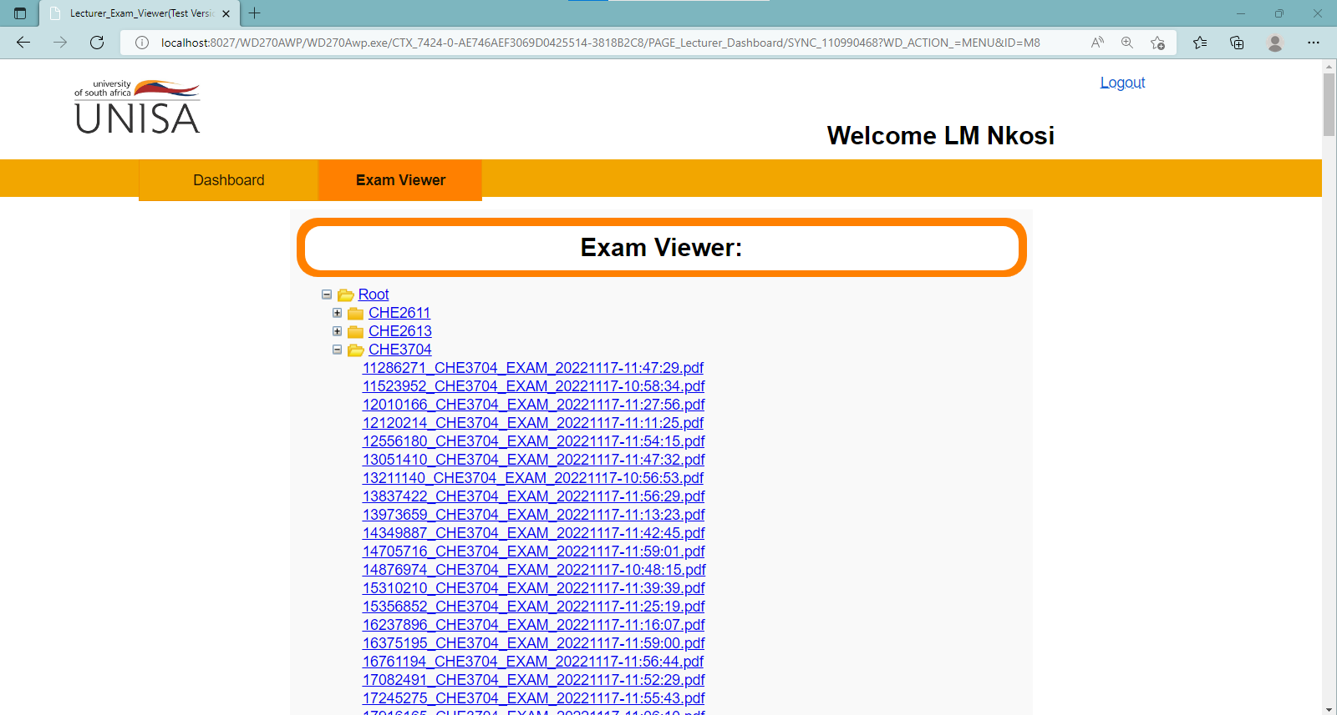

**Exam Department dashboard**

In the dashboard, all the reports can be accessed from a sidebar. The detailed selected MIS Report is displayed along with a drop-down list of all the modules written for the day with their respective details, such as Module leader, email and number of students to write.

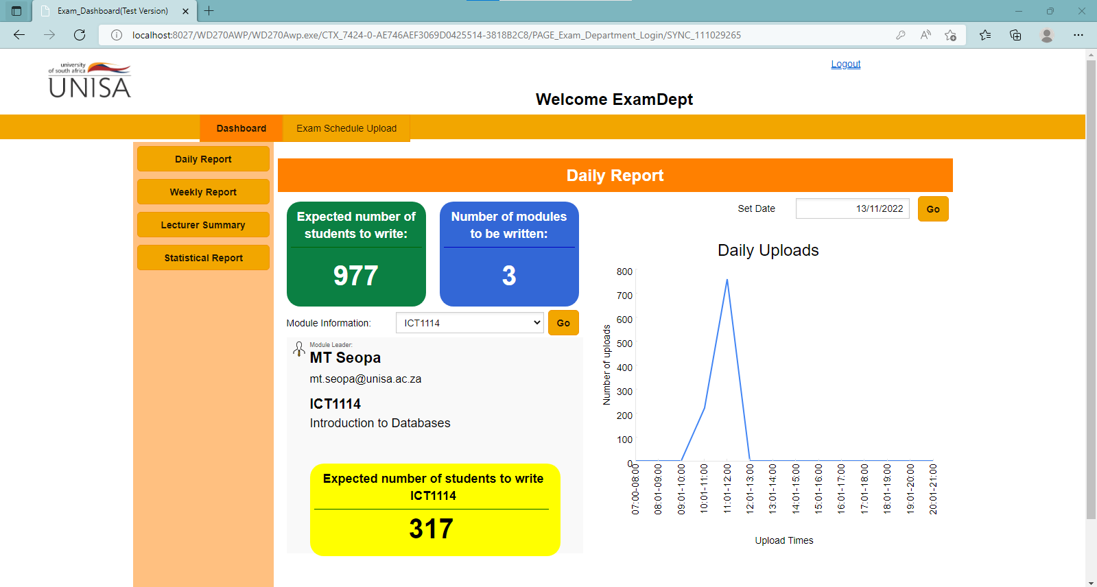

Student name and Surname: ______Ralph Botes___________

Student number: _____65614968_____________

___________________________ _05-10-2022_

Student signature: Date: